**EXPERIMENT NO. 5**

**AIM:** Study and Implementation of IP Addressing Schemes

**MATERIAL AND REQUIREMENTS**:

* Computers or laptops
* Network simulation software (Cisco Packet Tracer)

**INTRODUCTION**:

IP addressing is a fundamental aspect of networking. Understanding various IP addressing schemes and their practical implementation is crucial for network administrators and engineers. In this practical, students will study and implement IP addressing schemes, gaining hands-on experience in IP address assignment.

**PROCEDURE:**

**Part 1:** Introduction and Theoretical Study

**Overview of IP Addressing:**

* IP addressing is a system used to assign unique numerical labels to devices on a computer network, enabling data to be routed to its destination. It includes both IPv4 (e.g., 192.168.1.1) and IPv6 (e.g., 2001:0db8:85a3:0000:0000:8a2e:0370:7334) address formats. Subnetting, private/public IP addresses, CIDR notation, and NAT are important concepts within IP addressing.

**IP Address Classes:**

IP address classes are used to categorize and allocate IP addresses in IPv4 networks. There are five IP address classes, denoted as A, B, C, D, and E. These classes determine the range and intended use of IP addresses. Here's a brief overview of each IP address class:

1. **Class A (1.0.0.0 to 126.0.0.0):**
   * Class A addresses have a leading bit of 0 in their binary representation.
   * They are typically used by large organizations and corporations due to the vast number of host addresses they provide.
   * The first octet represents the network, and the remaining three octets are for host addresses.
   * Example: 10.0.0.1
2. **Class B (128.0.0.0 to 191.255.0.0):**
   * Class B addresses start with '10' in binary.
   * They are suitable for medium-sized networks, such as universities or regional networks.
   * The first two octets are reserved for the network, and the other two octets are for hosts.
   * Example: 172.16.0.1
3. **Class C (192.0.0.0 to 223.255.255.0):**
   * Class C addresses begin with '110' in binary.
   * They are commonly used by small businesses and home networks.
   * The first three octets represent the network, and the last octet is for host addresses.
   * Example: 192.168.1.1
4. **Class D (224.0.0.0 to 239.255.255.255):**
   * Class D addresses start with '1110' in binary.
   * They are reserved for multicast group addresses, used for efficient one-to-many and many-to-many communication.
   * Class D addresses are not used for general host-to-host communication.
5. **Class E (240.0.0.0 to 255.255.255.255):**
   * Class E addresses begin with '1111' in binary.
   * They are reserved for experimental and research purposes, and their use is limited.

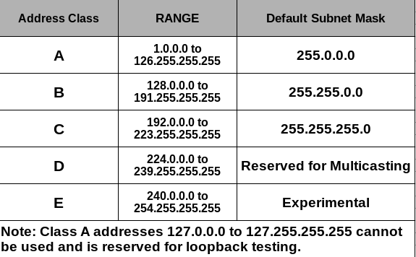

**Subnetting and CIDR:**

* Subnetting is the practice of dividing a single large network into smaller, more manageable subnetworks. This helps optimize IP address utilization and enhances network management. It involves creating subnets by borrowing bits from the host portion of an IP address, allowing for multiple smaller networks within a larger one.
* CIDR, or Classless Inter-Domain Routing, is an addressing scheme that provides a flexible way to allocate and subnet IP addresses. It uses a slash notation (e.g., /24) to denote the number of bits used for the network portion of the address. CIDR enables efficient address space management and is integral to the modern internet, allowing for more precise routing and address allocation.

**Private vs. Public IP Addresses:**

* + - A public IP address is a unique address assigned to a device or network that's directly accessible from the internet. It's used for communication across the global web.
    - A private IP address is assigned to devices within a local network, making them accessible only within that network. These addresses are not directly reachable from the internet and are used for internal communication.

**Part 2: IP Address Implementation**

**Practical Implementation:**

Step 1: Create a Lab in Packet Tracer. ...

Step 2: Access Command Line Interface. ...

Step 3: Enter the Privileged EXEC Mode. ...

Step 4: Switch to Global Configuration Mode. ...

Step 5: Change the router name. ...

Step 6: Assign IP Addresses.

